<http://www.ted.com/talks/andrew_blum_what_is_the_internet_really>

Andew Blum…

Architect builds a building

Many architects build a city

Over the last several years – less out in the world and more on my computer screen.

10 years online.  
4 – 5 years online all the time.

Infinite expanse of the Internet. We cannot understand it as a whole due to the expanse.

A squirrel was chewing on your Internet.

Is the Internet a place you can visit?

Looking for this thing that you cannot touch.

These places of the Internet – Data centers that use as much power as a city itself. Hudson street – very large data center.

Large cable that connects to another cable. 60 Hudson = Home of 6 networks – connect Oceans. If the Internet is a global phenomena – it’s because of cables like this.

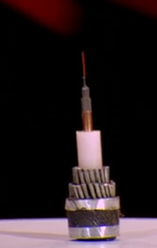

3-4 miles in length at a time. Light goes in on one end, and goes out on the other. Amplifiers every 15 miles. Basic unit is 10GB/s. 10,000 video streams. There are 50 – 70 wavelengths of light in each cable and there are 8 cables. Halifax for Ireland = manhole.

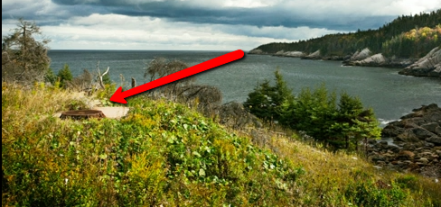

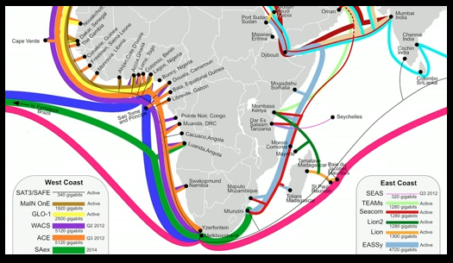

One cable is not enough. Africa had one, then later added another 5 cables to ensure it was a permanent connection.

Simon Cooper – TATA 🡪 The man inside the Internet. Bought two cables – One on Atlantic and one on Pacific. Built it around the world. If one broke, it could send the other direction. Looked for unwired connections (north to south.) – Africa.

See a cable being built. Physical corralary 🡪 WACS – west Africa cable system. South of Lisbon – guy walks out the wire – first link between sea and land. Bulldozer pulled cable in. Prepared the cable – hacksawed the interior – then lined up the hairline fibers with a hole punch machine. Internet is now a physical thing 🡪 the physical process has been around a long time. Lisbon, Mumbasa, Mumbai, Singapore, New York. Put manhole cover on, push sand over it, and we forget about it.

Wired people should know something about wires. We should know what physically connects us all.